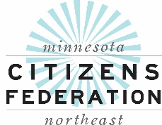

Senior Partners Care Program Application
Administered by Senior Community Services

Please fill in all questions on this application. If a question does not apply, please write “N/A”. Please print. Return the application with all proofs of income and assets together with a check made payable to “Senior Partners Care” in the amount of $42.00 per person.
How many are applying for SPC: ______ SPC ID NUMBER ________

Name: ___________________________________________________ DOB: _________________
Last First MI
Marital Status of Applicant (Circle): Married - Single - Divorced - Widowed - Legally Separated

Spouse: _________________________________________________ DOB: _________________
Last First MI

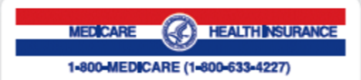
SELF: _______________________________
Medicare Claim Number: (include Letter)
_____________________________________
Effective Date:
Part A: ____________________________
Part B: ____________________________

Address: _____________________________ Apt: ________ Phone: (____) ________________
SPOUSE: _____________________________
Medicare Claim Number: (include Letter)
______________________________________
Effective Date:
Part A: ______________________________
Part B: ______________________________

City: _______________________ County: _________________ State: ______ Zip: ________

E-mail address: _____________________________________________________________________

Emergency or Alternate Contact: __________________________________________________

Phone number: (_____) ______________ Relationship: _________________________________

Name of clinic you usually use: ___________________________________________________

Name of Hospital you usually use: ___________________________________________________

- Do you or your spouse (if applying) have health insurance besides Medicare?  (exclude a Part D drug only policy). If Yes, describe: | Yes | No
- Do you or your spouse (if applying) have Medical Assistance, even with a spenddown, from your County?  If Yes, describe: | Yes | No
- Do you have SLMB or QI-1 paying for your Medicare Premiums?  SLMB ________ QI-1 __________ | Yes | No
If applicant answers yes to questions 1 or 2 above, applicant is not eligible for Senior Partners Care.

FINANCIAL INFORMATION
You must provide copies of proof of income and assets. Attach a complete copy (all pages) of your verification documents.
Senior Partners Care 2018 Guidelines
MAXIMUM GROSS Household Income:  ● Single individual: $2,023.00 ($24,280/year)  ● Married couple: $2,743.00 ($32,920/year) | MAXIMUM Household Assets  (EXCLUDES your home; one car; personal property)  ● $50,200.00 in total value
Based on 200% of Federal Poverty Guidelines | Based on 200% FPG for family of four.
These amounts change annually.

Your Current GROSS MONTHLY INCOME for all individuals (ATTACH PROOF) Indicate -0- if you have none |  |  |  | Your Current Assets in Value for all individuals (ATTACH PROOF) Indicate -0- if you have none
 | Self | Spouse |  |  | Self | Spouse
Social Security  Attach 2018 SS Award Letter(s) | $ | $ |  | Cash; Saving; and/ or Money Market  Attach Bank Statements** | $ | $
Pension(s)  Attach Stub, Letter or Statement | $ | $ |  | Checking Accounts; Debit Cards Attach Debit Card Print Out or Bank Statements** | $ | $
Interest/Dividends  Attach a company/brokerage statement | $ | $ |  | IRAs; Stocks; Bonds; CDs; Trusts; Annuities, 401k’s, 403b’s etc. Attach brokerage statements | $ | $
Employment Income  Attach 3 months of Pay Stubs | $ | $ |  | Non-Homestead property - Land you do not live on Attach Tax Statement | $ | $
Self-Employment – NET  Copy of IRS 1040 Schedule C | $ | $ |  | Additional Licensed vehicles: Provide make, model, year and Mileage for each  Indicate -0- if you only have one vehicle. | $ | $
Rental Income you receive – NET  Copy of IRS 1040 Schedule E | $ | $ |  | Boats, RVs, 4- wheeler, etc. Provide VIN and mileage /hours for each | $ | $
Spousal Maintenance (Alimony): Copy of Checks, Bank Statement, or Order | $ | $ |  | Rental Units you own  Taxable Market Value Statement | $ | $
Other Income: | $ | $ |  | Life/Burial Insurance Attach Face Page with Cash Value or Letter | $ | $
 |  |  |  | Other: | $ | $
Total Monthly Income | $ | $ |  | Total Assets | $ | $
GRAND TOTAL | $ |  |  | GRAND TOTAL | $
** Include ALL household bank accounts including Direct Express or other debit card accounts where your Social Security is deposited. SHOW ONE MONTH’S DEPOSITS in each, explain any deposits that are not your Social Security, pension or wages.
Do not send original documents. Send copies. Avoid using staples.

STATEMENT OF UNDERSTANDING
(Please read and sign. The signatures of the applicant and spouse are required.)

You understand that Senior Partners Care is a community service program; it is not health insurance.

You understand that enrollment in Senior Partners Care may be denied if:
- You do not meet the income and/or asset guidelines for the program; or
- Information furnished on (or attached to) this application is found to be inaccurate; or
- You currently receive Medical Assistance or Qualified Medicare Beneficiary (QMB) program benefits through the county where you reside and/or the Minnesota Department of Human Services.

You have listed your choice of Health Care Provider(s) and understand that not all Health Care Providers participate in this program.

You understand that Senior Partners Care does not provide a waiver for all health care expenses. You will be responsible for paying for services not covered by Medicare (i.e. routine annual physical) and services from Health Care Provider(s) who do not participate in Senior Partners Care.

You understand that you are not required to provide the personal, medical and financial information requested. However, failure to provide the information will result in failure to qualify for Senior Partners Care.

You understand Senior Community Services will keep your medical, personal and financial data private and will only use such data as necessary for the operation of the Senior Partners Care program. Information about eligibility for Senior Partners Care may be share with Health Care Providers who participate in the Senior Partners Care Program.

You certify with your signature below that you have read this entire application and that the personal and financial information provided here is complete and accurate to the best of your knowledge.

You grant permission to Senior Partners Care to contact your emergency contact, if necessary.

You will contact the Senior Partners Care if your insurance or Medical Assistance status changes.

If married, both partners must sign, even if only one partner is applying.

Applicant _______________________________________ Date _____________________
(Written Signature)

Spouse ________________________________________ Date _____________________
(Written Signature)

Senior Partners Care is not insurance so there are no monthly premiums. The yearly application processing fee is $42.00 per person. This fee must accompany the application. If you do not qualify for the program, the application fee will be refunded. Submit a check/money order for $42 per person payable to Senior Partners Care with your application and verifications to:

Senior Partners Care
10201 Wayzata Blvd, Suite 335
Minnetonka, MN 55305
r.jordan@seniorcommunity.org

Call with questions: 952/767-0665; Fax: 952/541-0841
Approximately 30 days after of receipt of your application, Senior Partners Care will notify you of acceptance or denial into the program. This period will be extended if additional information is required from the applicant.

FOR OFFICE USE ONLY
Approval/Disapproval date: ______________________ □New □Renewal □Denial
Accepted Effective Date: ________________________ □Fee Paid □$42 □$84

Qualify/Denial Reason: _________________________ Member ID ______________________

Spouse ID ______________________
Hospital Coordinator ____________________________ □ Copy sent
SPC Rep initials ________________

Notes:

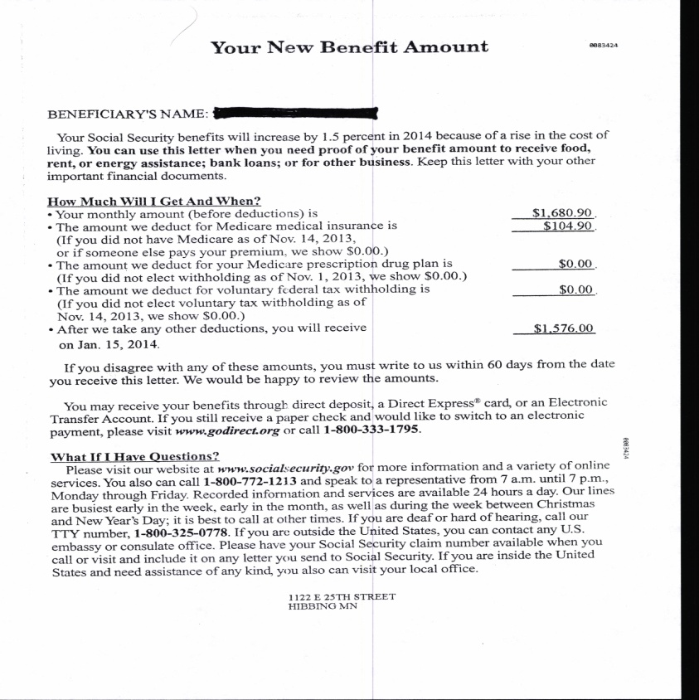
EXAMPLE OF A SS AWARD LETTER
PLEASE PROVIDE YOUR 2018 SOCIAL SECURITY AWARD LETTER. IT IS REQUIRED.
- We no longer accept Social Security direct deposit line item entries on your bank statement or Form SSA-1099 as proof of income.
- Call Social Security at 1-800-772-1213 to request a copy. OR
- Go to www.socialsecurity.gov to print a copy. Under My Home/ Replacement Documents. Go to the Medicare Card to Need Proof. Click and print a Benefit Verification Letter.
- If you have Direct Express, get a printout from your ATM. It must have your name, account number, etc.

